Cell Count Pipeline Protocol
Anirudh Chinthakindi and Daniel Etcheberrigaray

1. Overview of the pipeline
Each slide of sections moves through six stages:
- Acquisition produces a slide of sections saved as .nd2 files.
- NeuroInfo registers each section to the atlas, defines the ROIs to analyze, and exports contours as .xml plus a flattened .jpx stack.
- A conversion script turns each .nd2 into a .tif.
- FIJI (ImageJ) converts the NeuroInfo .xml contours into native FIJI ROI files, applies background subtraction to the tifs, and clears out unnecessary information lying outside of the key ROIs.
- ilastik (Pixel Classification) classifies pixels as cell vs. background with a Random Forest model and exports probability maps as .tif
- FIJI thresholds the probability maps and counts cells within each ROI using size and circularity filters.
Data flow: nd2 → (xml + jpx) + tif → Fiji ROIs → background-subtracted tif → ilastik probability tif → thresholded count per ROI (results).
Required and optional steps. The six stages above are done for every slide. The scripts also include some optional steps. Whether you use them depends on your experiment; none of them is needed to get cell counts. The table below lists every step and when the optional ones are useful. In the rest of the protocol, optional steps are marked "Optional" in their heading.
Step (script) | Required? | When to use it
Map the experiment folders (Map Experiment Folders, section 5.1) | Recommended | Once per experiment. It records the day, treatment and animal of each slide, and stage 5 then adds those columns to the counts table. It is required only for Tune Counting Parameters; without it, every other step works as before.
One folder per brain region (Set Up Slide Folders, section 5.2) | Optional | Only when you count more than one brain region on the same slides and want separate ROIs and counts for each. With one region per slide, keep the layout in section 3.
Run the stages on every slide of an animal (Run Stages for an Animal, section 5.3) | Optional | When an animal has several slides: runs the Fiji scripts of Stages 2 to 5 and the composite (section 13) on all of them, slide by slide, with one set of settings.
NeuroInfo registration and export (Stage 1) | Required | Every section.
Convert nd2 to tif (1 Convert to Tif, Stage 2) | Required | Every slide.
XML to ROIs (2a NeuroInfo XML to ROI, Stage 3) | Required | Every slide.
Review and edit ROIs (2a.i Review and Edit ROIs, Stage 3) | Optional | When some NeuroInfo outlines do not fit the tissue and you want to correct them by hand.
Background subtraction and clearing (2b BG Subtract and Clear, Stage 3) | Required | Every slide.
Train the ilastik classifier (ilastik window, Stage 4) | Required | Once per slide (or per region).
Run the classifier on every image (Stage 4) | Required; the route is your choice | Either ilastik's Batch Processing window, as described in Stage 4, or the optional 2c Run ilastik Headless from Fiji, which sets the export settings for you.
Choose the counting parameters | Required; the method is your choice | By trial and error, with 0 Optimize Parameters (section 12), or with the optional Tune Counting Parameters, which uses blind hand counts (section 10).
Count cells (3 Count Particles per ROI, Stage 5) | Required | Every slide.
Check the results (4 Build Pipeline Composite, section 13) | Optional (recommended) | On a few sections of each slide, to see that detected cells match visible cells.

2. Software and inputs
Tool | Role in pipeline
NIS-Elements / microscope | Produces the raw .nd2 slide scans
NeuroInfo (NI) | Section-to-atlas registration, ROI selection, .xml and .jpx export
Conversion script | Batch .nd2 to .tif with preserved naming
Fiji (ImageJ) | .xml to ROI conversion, background subtraction, thresholding, particle counting
ilastik (Pixel Classification) | Random Forest pixel classification, probability-map export

Custom scripts to keep together in the pipeline folder:
- 1 Convert to Tif (.nd2 / .ims to .tif conversion)
- 2a NeuroInfo XML to ROI (.xml to Fiji ROI)
- 2b BG Subtract and Clear (background subtraction and clear outside the tissue ROI)
- 3 Count Particles per ROI (thresholder + cell counter)
- 4 Build Pipeline Composite (image combiner to audit cell count)
- 0 Optimize Parameters (tries a range of values for one parameter so you can pick the best one)
- Map Experiment Folders (recommended: a table of the day, treatment, animal and slide of every slide folder)
- Set Up Slide Folders (optional: one folder per brain region in each slide)
- 2a.i Review and Edit ROIs (optional: correct ROI outlines by hand)
- 2c Run ilastik Headless (optional: run a trained ilastik classifier from Fiji)
- Tune Counting Parameters (optional: choose the counting parameters from blind hand counts)
- Run Stages for an Animal (optional: run the stage scripts on every slide of one animal)
Installing the software (once per computer). The lab computers run Windows. Install the following.
- Fiji: download the Windows 64-bit version from imagej.net/software/fiji/downloads and unzip it to a folder you can write to, for example C:\Users\<your name>\Fiji.app (not inside Program Files). Start Fiji by double-clicking the Fiji program inside Fiji.app.
- The Kapur Lab scripts: copy the Kapur Lab Cell Counting folder (the one that holds the Batch and Single Image folders) into Fiji.app\scripts\Plugins\. Restart Fiji. The scripts then appear under Plugins > Kapur Lab Cell Counting, in two submenus, Batch and Single Image. Map Experiment Folders, Set Up Slide Folders, Tune Counting Parameters and Run Stages for an Animal are directly in that menu, above the two submenus. To update the scripts later, delete the old Kapur Lab Cell Counting folder in Fiji.app\scripts\Plugins\ first, then copy in the new one and restart Fiji. Copying the new folder over the old one keeps scripts that were renamed, so the menu shows old and new versions side by side.
- ilastik: download the Windows installer from ilastik.org/download, run it and keep the folder it suggests (C:\Program Files\ilastik-<version>). Use the same ilastik version for a whole experiment.
- A spreadsheet program such as Excel, to check the experiment table (section 5.1) and to open the results.
Batch or Single image. Every stage script comes in both versions. A Batch script processes every section of the slide. A Single image script processes one section you choose and, by default, leaves the result open on screen so you can check it. Both versions use the same settings and write the same files to the same folders. Use Single image to try settings on one section, then run Batch on the whole slide.
Picking the slide folder. Each stage script asks for one folder, "Slide folder (the scripts find its subfolders)", and finds xml/, tifs/, rois/ and the other subfolders inside it. If you made region folders (section 5.2) and a slide has more than one (for example hippocampus MBF and dg MBF), a drop-down list opens after you click OK, showing each region folder with how many xml files, ROI sets and probability maps it holds. Pick the one you are analysing. Whatever you typed in "Region" (for example dg) is preselected, otherwise your last choice; a slide with only one region folder uses it without asking. A Single image script also asks for "Section" (for example Region0011; leave it blank to choose from a list). A window then shows the folders and files that were found, so you can correct any that are wrong.
Check settings window. Before anything is processed, each script lists what it is about to do. Lines starting with WARNING point out likely mistakes, for example probability maps that are older than the images they came from. Press Run to go ahead, or Cancel to stop without changing anything.
Running a script. Every script is run the same way:
- In Fiji, click Plugins > Kapur Lab Cell Counting and choose the script (in Batch for a whole slide, in Single image for one section).
- A window opens with the settings. Click Browse next to "Slide folder" and choose the slide's own folder (the one that holds nd2/, tifs/ and the other subfolders, not one of the subfolders). Map Experiment Folders, Set Up Slide Folders and Tune Counting Parameters ask for the experiment folder instead, and Run Stages for an Animal for the animal folder. Check the other settings, then click OK. Fiji remembers the values you used last time.
- A second window shows the folders and files the script found. Check them and click OK.
- The Check settings window lists what will happen. Read any WARNING lines, then click Run.
- Progress is shown in the Log window and in the status bar of the Fiji window. At the end, a message says what was made and where. If something is wrong, a message explains the problem: fix it and run the script again. The scripts write new files and leave their input files unchanged; the exceptions are 2a.i Review and Edit ROIs, which saves your edits (keeping the originals), and Set Up Slide Folders, which moves folders.
Records and reference. Every run saves a parameter record (_run_<script>_<date-time>.txt) in its output folder listing every setting it used. Every dialog field, setting and message is described in the separate script reference document (Kapur_Lab_Cell_Counting_Script_Reference.docx).

3. File structure and naming convention
Each slide gets its own folder (Slide 1, Slide 2, and so on) containing these subfolders:
Subfolder | Contents
nd2/ | Raw section images (.nd2 or .ims; they can also sit directly in the slide folder)
tifs/ | Converted images for processing
xml/ | NeuroInfo ROI contours
jpx/ | NeuroInfo flattened image stacks
rois/ | Fiji-native ROI files
processed_bgsub_cleared/ | Background-subtracted, cleared images (made by 2b; these go into ilastik)
probabilities/ | ilastik probability maps
particle_counts/ | Final cell-count table (particle_counts.csv), plus the images stage 5 saves (thresholded/, QC/ and, if chosen, particle_rois/)
optimization/, pipeline_composites/ | Optional: results of the optimization and composite scripts
Region folders (optional). If you count more than one region on the same slides (for example hippocampus and PAG), Set Up Slide Folders (section 5.2) can give each slide a folder per region, named after the region with the word MBF, for example "hippocampus MBF". It holds that region's xml/, rois/, processed_bgsub_cleared/, probabilities/ and particle_counts/, while tifs/ and jpx/ stay in the slide folder. With one region per slide, keep the layout in the table above.
Experiment table. Map Experiment Folders (section 5.1) writes experiment_layout.csv in the top folder of the experiment, above the day folders (for example Experiment/day 1/vehicle/A2F/Slide 1). If you use Tune Counting Parameters, it saves its result in the counting_tuning/ folder there, as tuned_counting_parameters_<region>.txt, where stage 5 finds it.

Naming rule: every derived file keeps the region identifier of the original .nd2 at the start of its name. The NeuroInfo files (.xml, .jpx) are saved with the region identifier only. The scripts keep the whole input name and only add to the end of it (for example _MAX_C2 or _bgsub). Files are paired between folders by the leading RegionXXXX token alone, so anything after it is ignored. Keep the region number identical across all subfolders.
Stage | Example filename
Original nd2 | Region0011_ChannelFITCTRITC_Seq0011.nd2
NeuroInfo xml | Region0011.xml
NeuroInfo jpx | Region0011.jpx
Converted tif | Region0011_ChannelFITCTRITC_Seq0011_MAX_C2.tif

4. Experiment-specific parameters
Parameter | Where it is used | Significance
Background subtraction value | Stage 3, 2b BG Subtract and Clear | Determines intensity of background subtraction. Must be set so as to not destroy information.
Threshold | Stage 5, 3 Count Particles per ROI | Determines pixel intensity threshold for image segmentation. Must not merge cells together.
Particle size range | Stage 5, 3 Count Particles per ROI | Determines size of particles that are counted as cells, must exclude noise.
Circularity range | Stage 5, 3 Count Particles per ROI | Determines circularity of particles that are counted as cells, must exclude non-cellular objects.
These values can be chosen by trial and error, with 0 Optimize Parameters (section 12), or with the optional Tune Counting Parameters (section 10), which picks the threshold, size and circularity values that best match blind hand counts. Whichever method you use, keep the values the same for every slide of an experiment.

5. Before you start: set up the experiment
Do this once per experiment, once the slide folders exist and before the stage scripts. Section 5.1 is recommended for every experiment. Sections 5.2 and 5.3 are optional.

5.1 Map the experiment folders (recommended)
- Arrange the slide folders by group, for example Experiment/day 1/vehicle/A2F/Slide 1. Folder names may vary between days; you can correct the table in step 3.
- Run Plugins > Kapur Lab Cell Counting > Map Experiment Folders. Give the experiment folder (the top folder, above the days) and the levels between it and the slides (default: day, treatment, animal). Slide folders that are still empty (no images copied in yet) are included too, so every animal is in the table.
- The script writes experiment_layout.csv in the experiment folder and opens it in your spreadsheet program. Check each row, correct any day, treatment or animal, and set include to no for slides to leave out of the analysis (for example a slide stained for another marker). In Excel, click Save and, if Excel asks, keep the CSV format. Then go back to Fiji and click OK. The script checks the table and lists any problem to fix.
- Run it again whenever slides are added. Your corrections are kept, and the previous table is saved as experiment_layout_previous_<time>.csv. Close the table in Excel before you run it again. If it is still open there, the script stops, asks you to close it and leaves the table unchanged.
What it changes. Each stage script names the slide's group in its Check settings window; stage 5 adds the day, treatment, animal and slide columns to particle_counts.csv; Set Up Slide Folders leaves slides marked include = no alone; and Tune Counting Parameters needs the table. If you skip this step, the stage scripts work as before and particle_counts.csv has no group columns. In Excel, format the level columns as Text before saving, or names such as 3-1 turn into dates.

5.2 Optional: one folder per brain region (Set Up Slide Folders)
Only needed if you count more than one brain region on the same slides and want separate ROIs, ilastik projects and counts for each. If you use it, run it before Stage 1 so that NeuroInfo's xml files go into the region's folder. Otherwise skip this section; the scripts work with the layout in section 3.
- Run Plugins > Kapur Lab Cell Counting > Set Up Slide Folders. Give the dataset folder (it is searched at every depth for slide folders) and the region being analysed, for example hippocampus. Keep the word MBF in "Added after the region name" (default " MBF"), because the other scripts recognise a region folder by it.
- The two subfolder lists say which folders go inside the region's folder and which stay directly in the slide folder. Choose whether existing subfolders in the wrong place are moved or left, and whether raw .nd2/.ims files stay in the slide folder or are linked or copied into nd2/. With "Leave them where they are", a folder such as rois/ found directly in the slide folder stays there untouched, and the region's folder still gets its own new, empty one, which the stage scripts use for that region. To use the existing ones for the region, choose "Move them to where they belong".
- A preview shows the planned folders for two slides. Check it, then run. Every move is listed in the parameter record, so it can be undone. Slide folders that are still empty (no images copied in yet) are set up too, as long as they sit at the same depth as the other slide folders.
- Run it once per region. In each stage script, type the region (for example hippocampus) into "Region".
Raw files in another folder. If the .nd2/.ims files are kept in a separate folder tree that repeats the folder names of the slide folders (day, treatment, animal, slide), with the raw files directly in each slide's folder there, give its top folder as "Raw data top folder". Set Up then makes every slide folder that tree has, and the slide folders hold only analysis files. Give the same folder as "Raw data top folder" in 1 Convert to Tif (Stage 2) and in Run Stages for an Animal.

5.3 Optional: run the stages on every slide of an animal (Run Stages for an Animal)
Runs the batch stage scripts you tick (1, 2a, 2b, 2c, 3 and 4) on every slide of one animal, one slide after another, with the same settings for all of them. Each slide is processed as if you ran the stage on it yourself: its files go into its own folders, its counts stay its own, and its region folder gets a record saying the slide was run as part of the whole animal. Slides of different animals are never run together.
- Run Plugins > Kapur Lab Cell Counting > Run Stages for an Animal. Give the animal folder (the folder that holds the animal's slide folders), the region (for example hippocampus), the raw data top folder if the raw files are kept elsewhere, and tick the stages.
- For each stage a window asks for its settings once; they are used for every slide. For 2c, choose the animal's ilastik project (saved in the animal folder) or each slide's own.
- The Check settings window lists every slide and what will run on it. A slide that lacks a stage's input is skipped for that stage, with the reason. Read the WARNING lines, then click Run.
- The run stops and waits at the steps that need you: before 2b BG Subtract and Clear, to review the ROIs (it can open 2a.i Review and Edit ROIs on one slide after another); before 2c Run ilastik Headless, to train ilastik (every slide has finished 2b by then; save the project in the animal folder); and before 3 Count Particles per ROI, to run Tune Counting Parameters if counting should use tuned values and none exist yet. The window stays open while you work: press Continue when the step is done, or Stop here to finish another day. The next run on that animal offers to continue where it stopped, with the same settings.
- Leave Fiji alone while the stages run. Press Esc to stop after the stage that is running. At the end a summary lists, for each slide, what was done. After stage 5 (3 Count Particles per ROI), the animal folder also gets particle_counts_all_slides_<region>.csv, the slides' tables one after the other with the slide named in each row.
Tune Counting Parameters draws its sections from the whole experiment, and stage 5 uses its values for every animal. Tuned while only this animal has probability maps, the values fit this animal. The Tune break shows how many slides of the experiment have maps; if most do not yet, press Stop here, make the other animals' maps, run Tune, then continue each animal's run.

6. Stage 1: NeuroInfo section-to-atlas alignment
A more detailed explanation of NeuroInfo’s capabilities can be found here and information specific to section registration can be found here.
Produces the xml and jpx files that every later stage depends on. Run the one-time setup once, then repeat the per-section loop for every section on the slide.

One-time setup (start of the session)
- Open NeuroInfo. Do this once. Every section in this session runs inside the same NI instance.

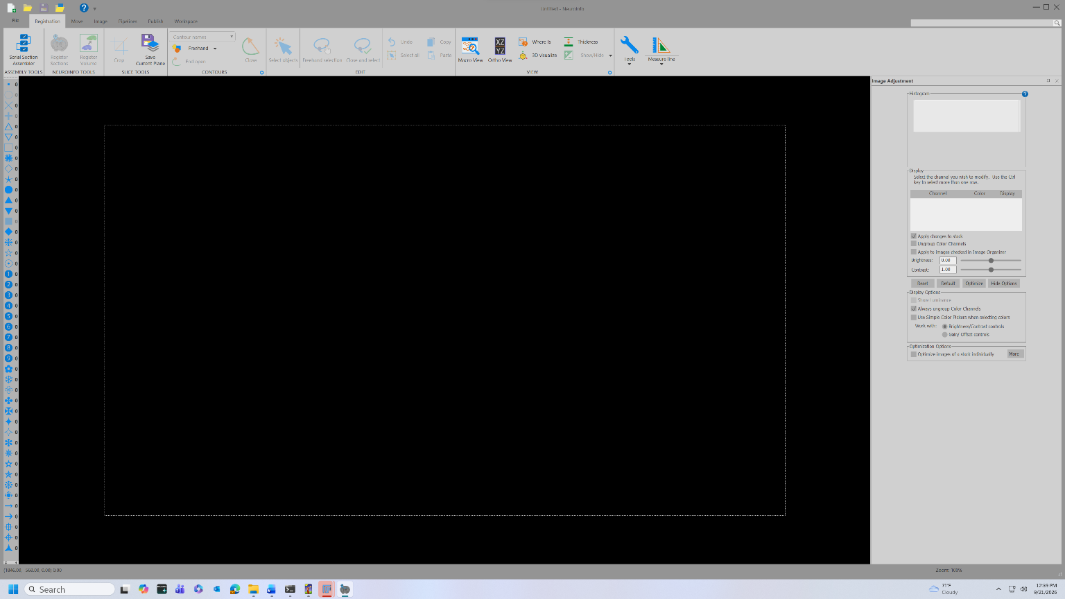

Load and prepare the section
- Drag the desired .nd2 file into the NI workspace.
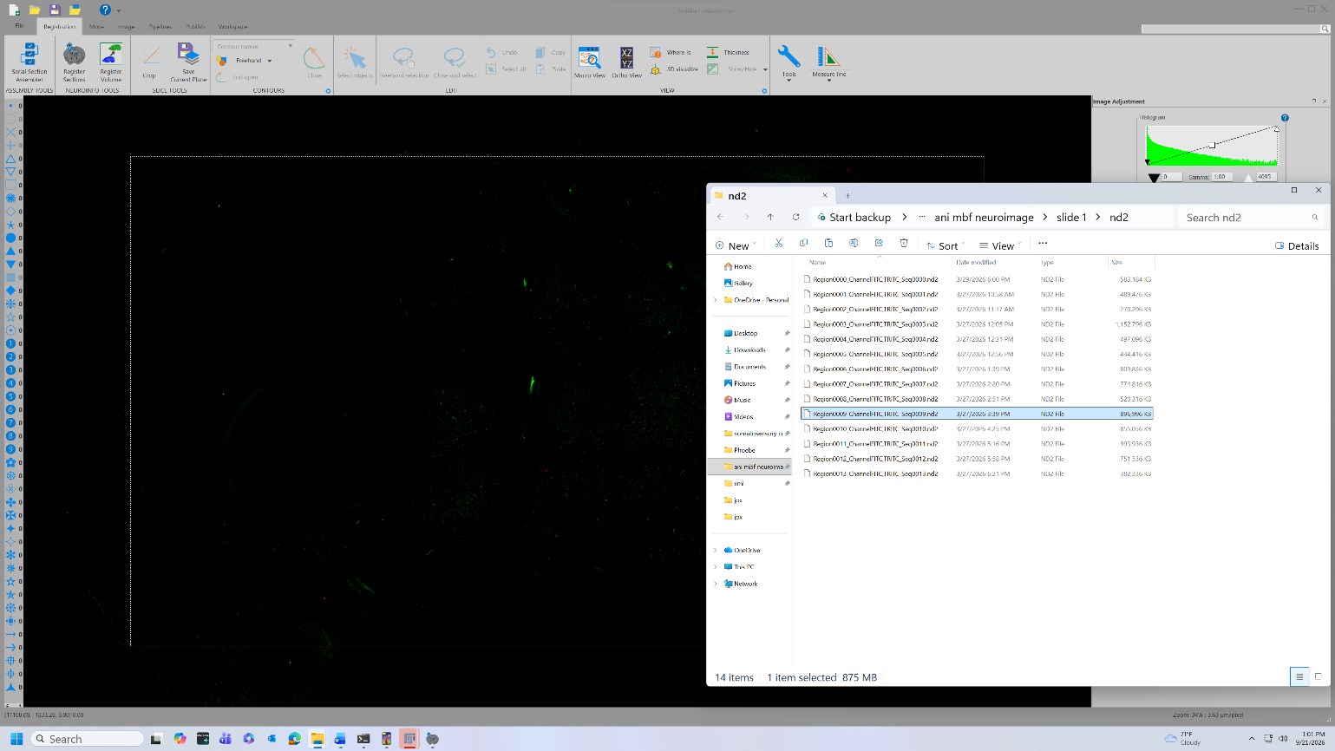
- In Image Adjustment, adjust the histogram for every fluorescence channel to optimal brightness.

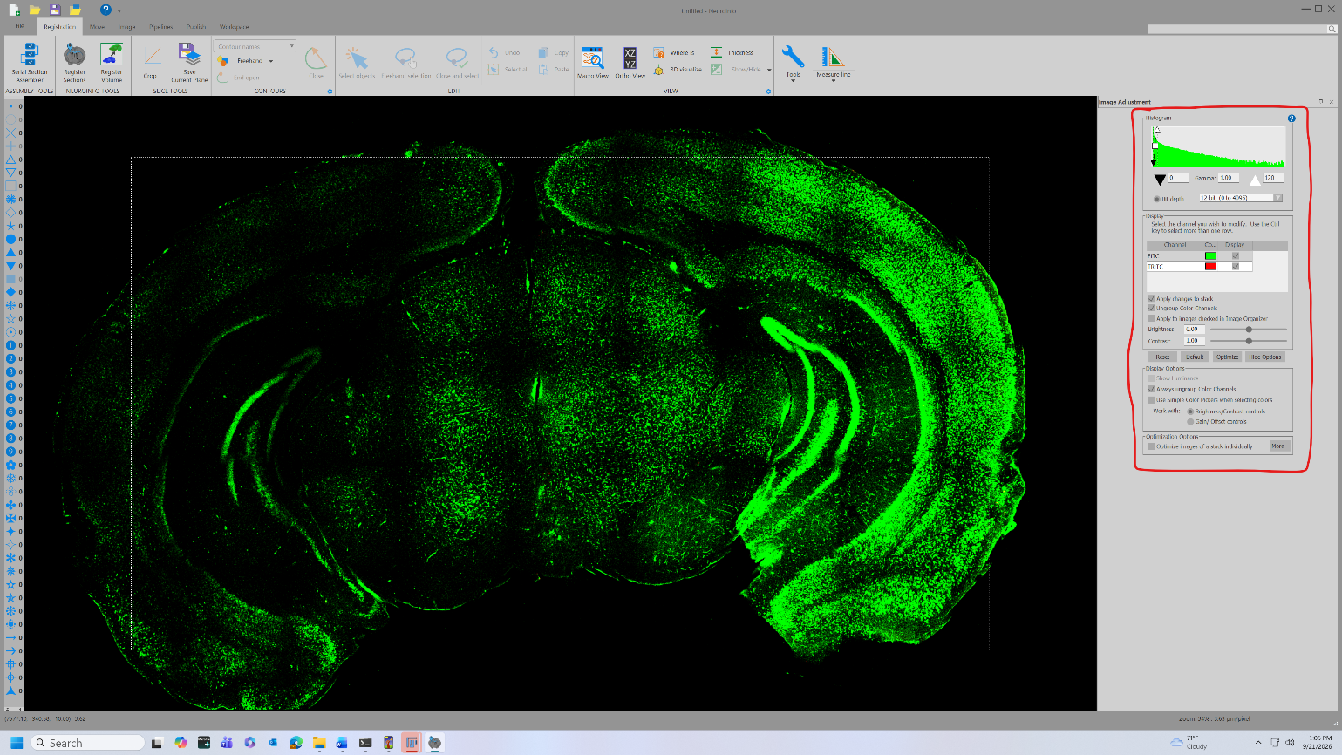

Register the section to the atlas
- Click Register Sections (top left).
- Select the optimal z-level for registration by scrolling through the 3D Slice Scroll bar on the right. You are looking for the most evenly lit-up slice.
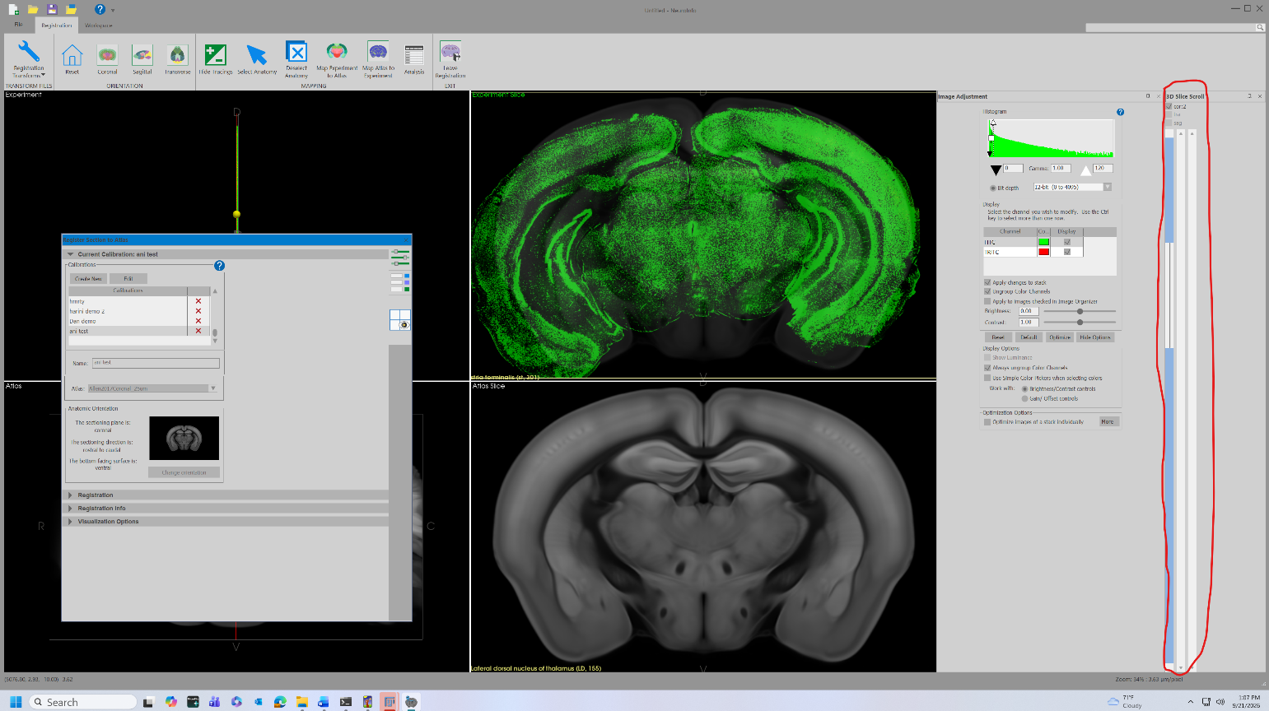
  - Use Visualization Options → “Show atlas over experiment slice” slider as needed to check the overlay while matching.
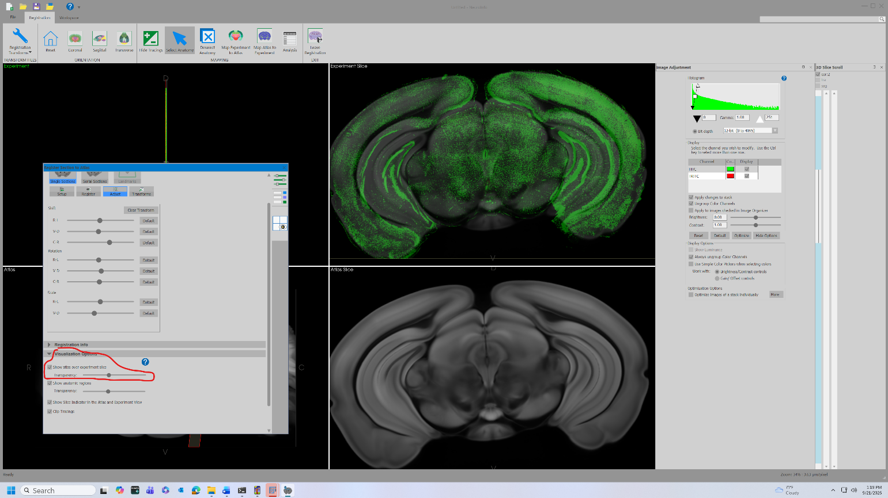
- In the Register Section to atlas window, open the ‘Registration’ tab and click on ‘Setup’. Click ‘Search’ to attempt an automatic registration.
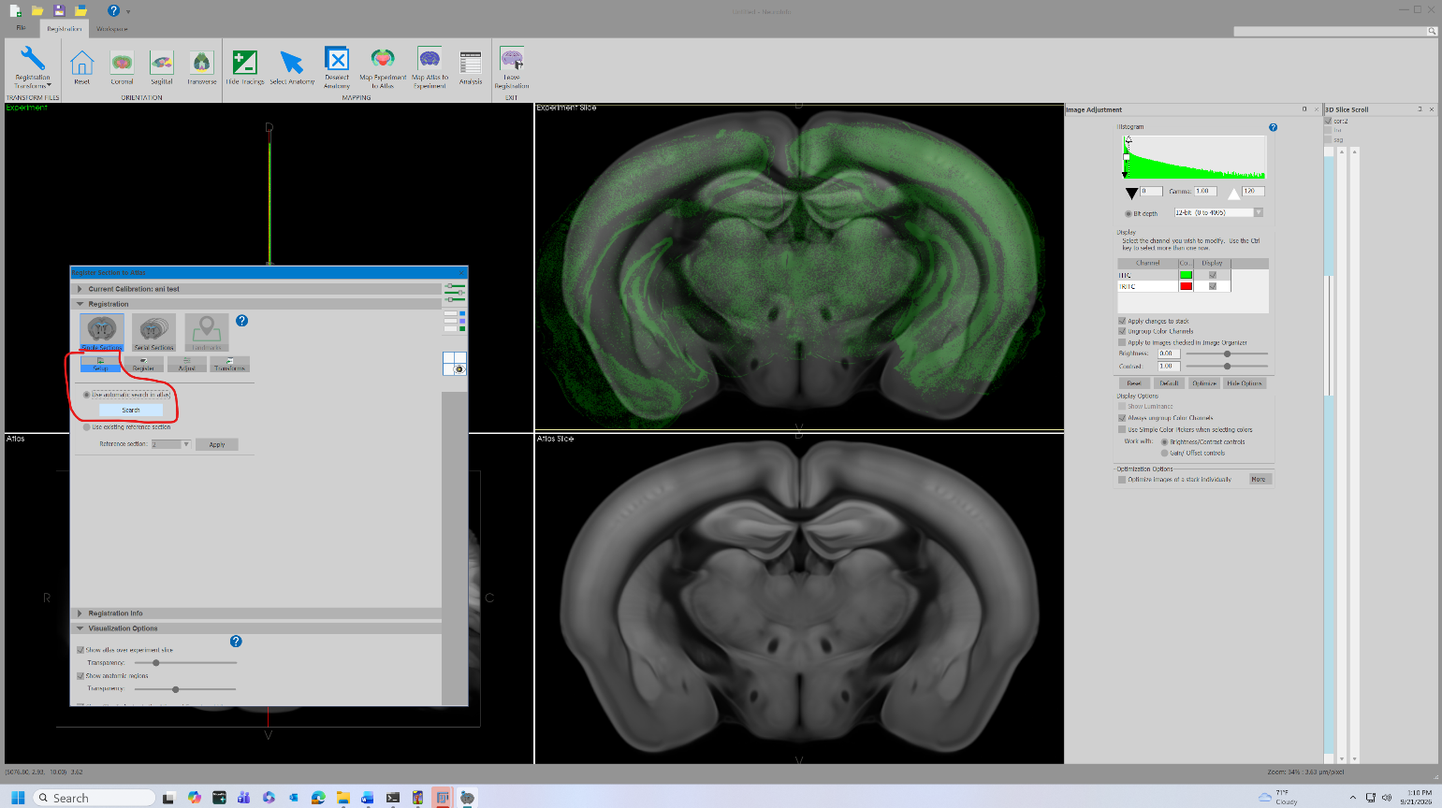
- If the registration is close, click on ‘Register’ and then ‘Run Linear’ to attempt automatic linear transformation. You can also try running this after manual adjustment.
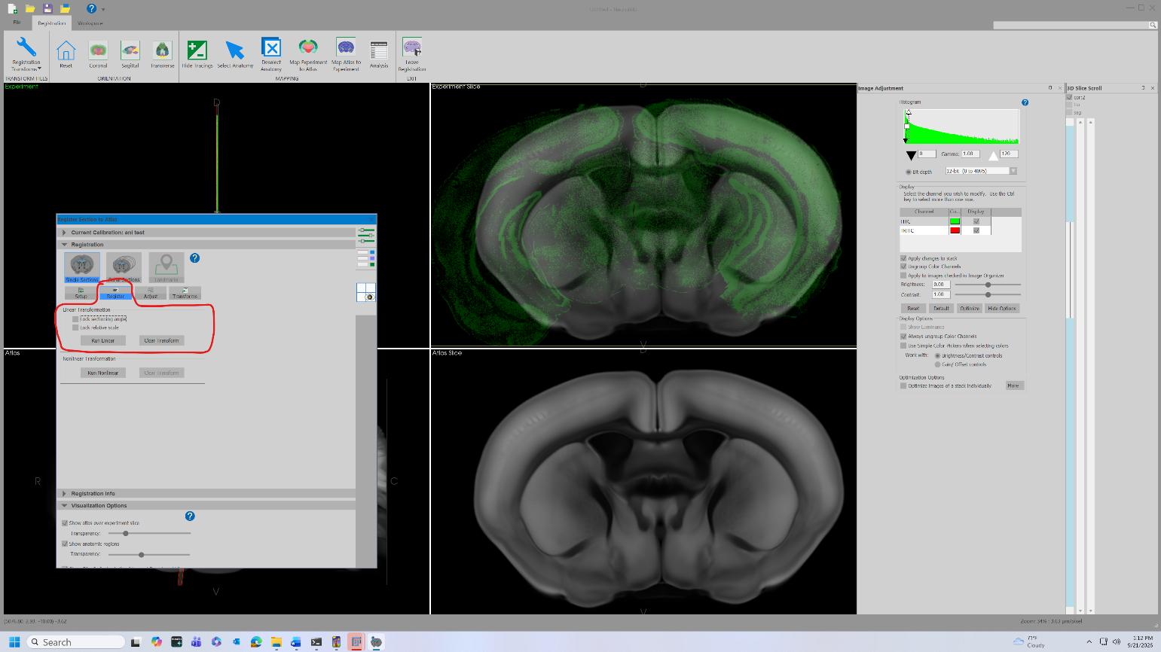
- Click on ‘Adjust’ and then use the various sliders to fine-tune the registration.
  - The automatic registration and transformation tools vary in effectiveness depending on the slice. You may have to use the manual Adjust sliders to perform the entire registration.
  - It can be helpful to click on the ‘Select Anatomy’ button at the top and then click on certain anatomical features to aid in your alignment.
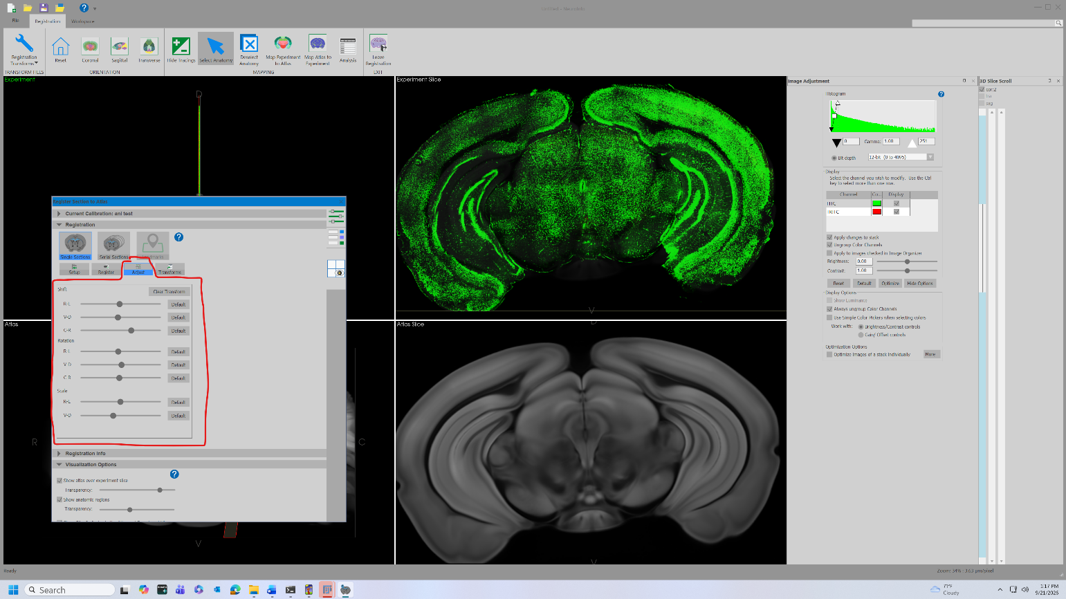
- Once the Atlas Slice fits the Experiment Slice, click the 2nd icon on the right of the Register Section to Atlas options pane (the one that looks like a list).
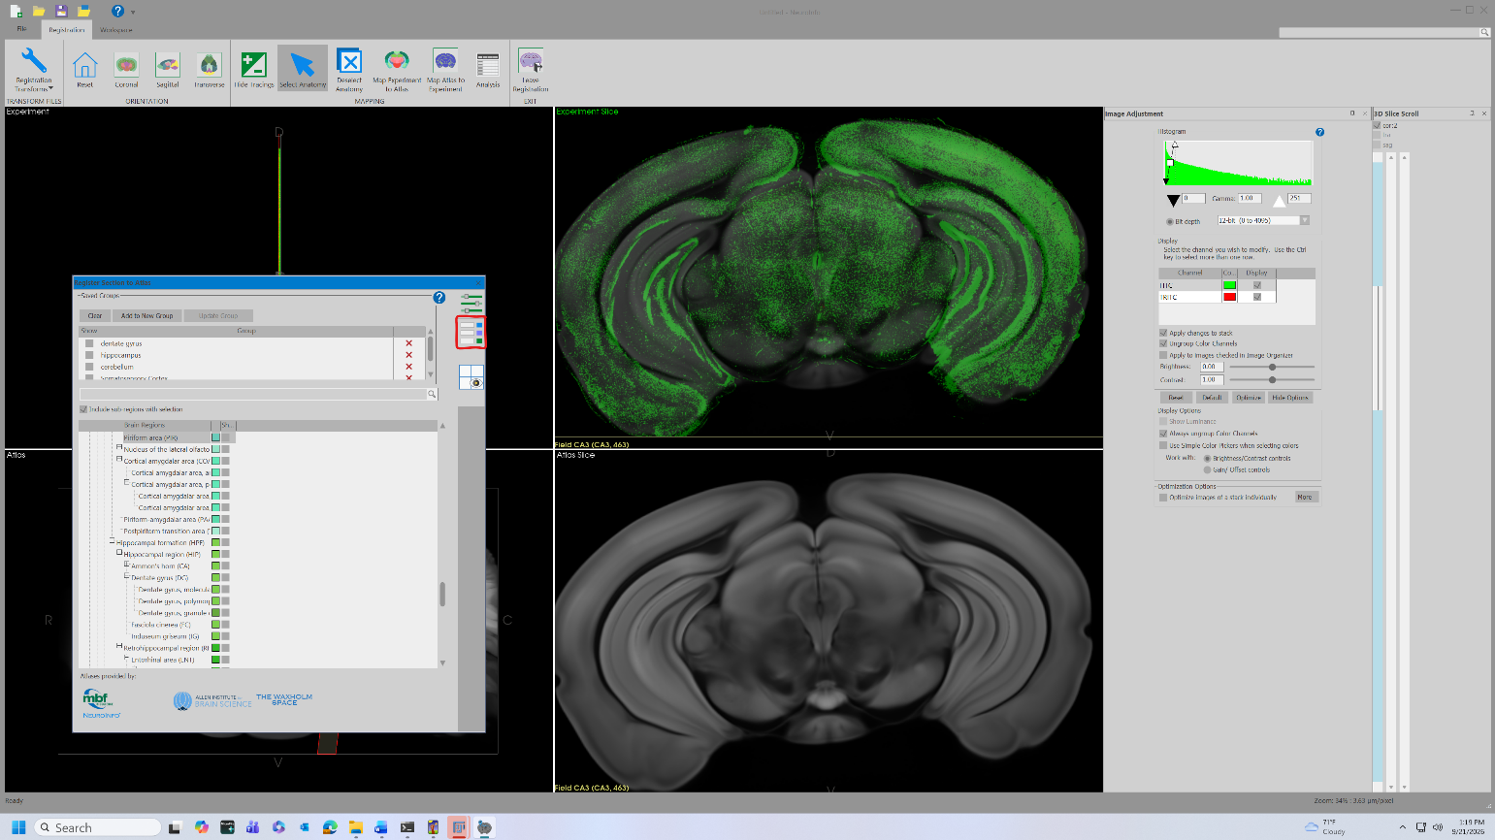

Select ROIs
- Click Select Anatomy in the top menu bar, then click each ROI to be analyzed.
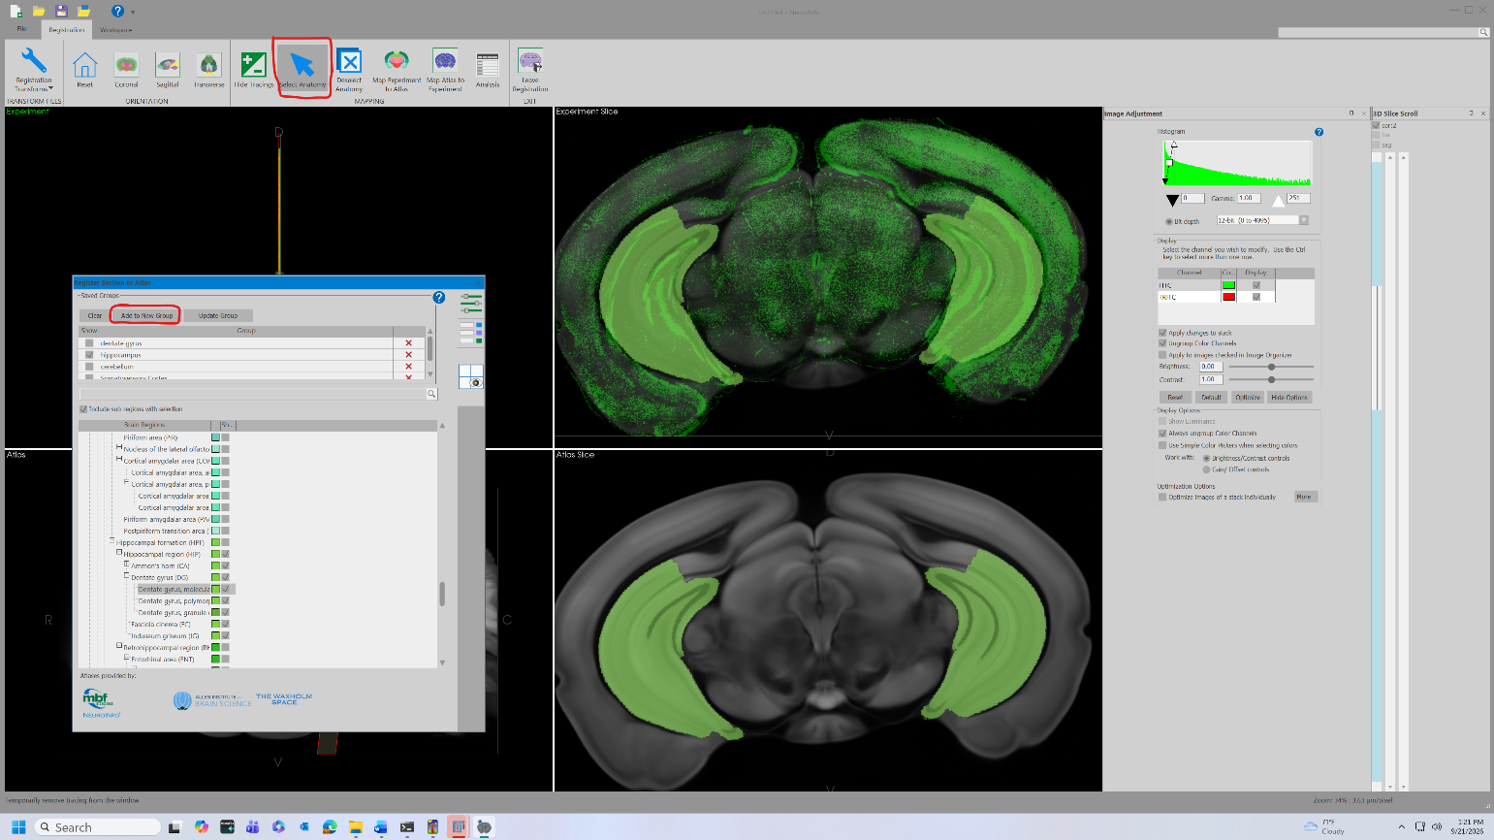
- In the Register Section to Atlas options pane, confirm that all desired ROIs are selected.
- Ensure that all desired ROIs match the anatomy on the Experimental Slice. If this is not the case, repeat step 7.
- Click Add to New Group and name the group according to the experiment. Note that if you have already made a group of the ROIs that you need for your experiment, you do not have to repeat these steps for every image.
To count several brain regions separately (for example hippocampus, somatosensory cortex, striatum and amygdala), select all of them in this one group. NeuroInfo exports each region with the regions inside it, and 2a NeuroInfo XML to ROI separates them (section 8). Keep "Separate contours by left and right hemispheres" ticked below so that each side can be counted on its own.

Map the atlas to the experiment
- Click Map Atlas to Experiment, then set the options below.
- Select All Planes
- Map brain regions in selected group, then choose your group
- Separate contours by left and right hemispheres
- Contour detail slider all the way to the right (to “Fine”)
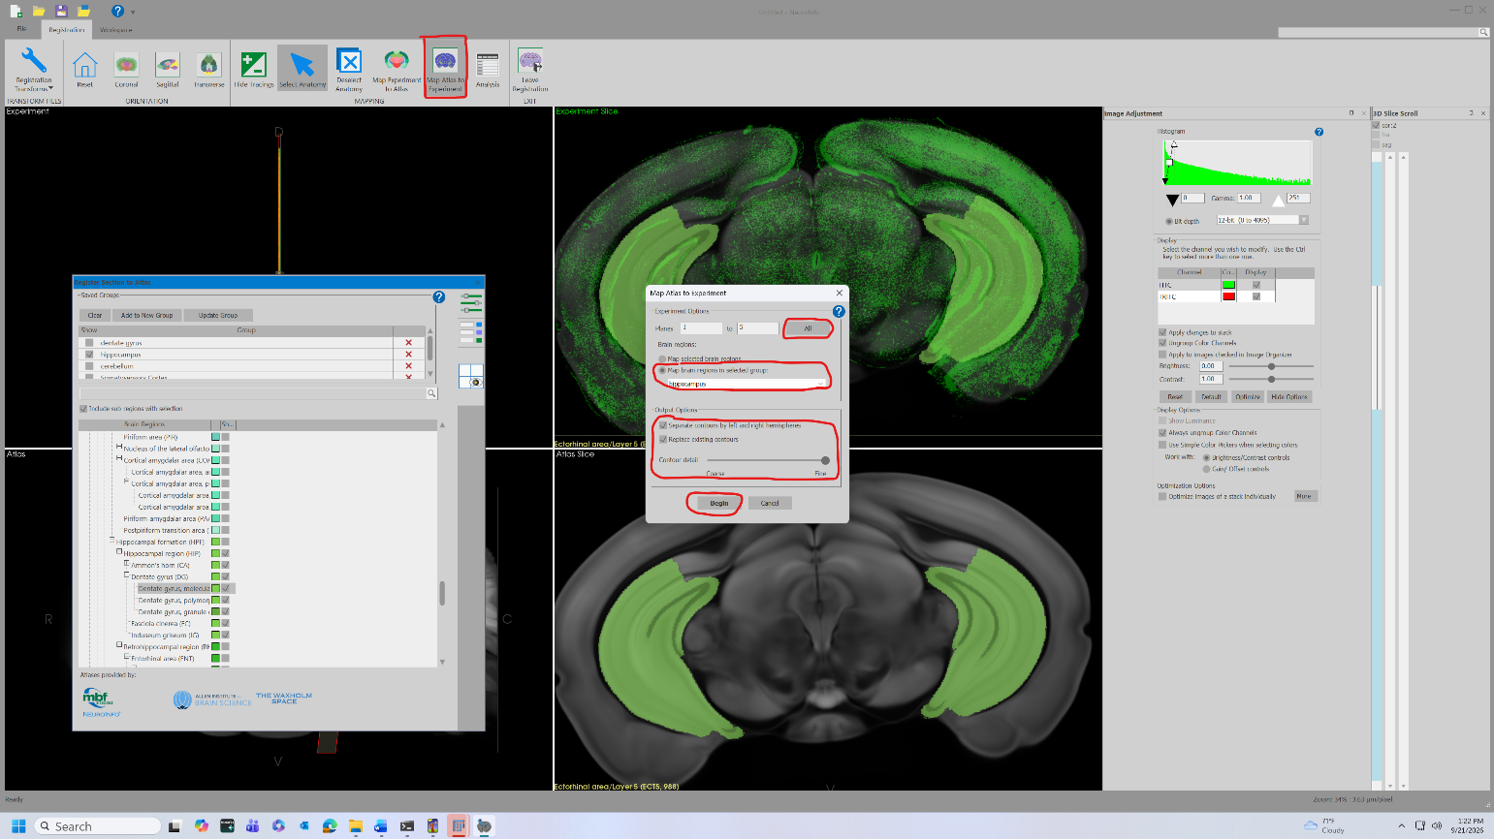
- Click Begin.

Export
- Press Ctrl + S. Save with the exact region-only filename (extra channel and sequence text removed) into the xml/ subfolder. If you made region folders (section 5.2), use the xml/ inside the region's folder.
Original: Region0011_ChannelFITCTRITC_Seq0011.nd2
Saved: Region0011.xml
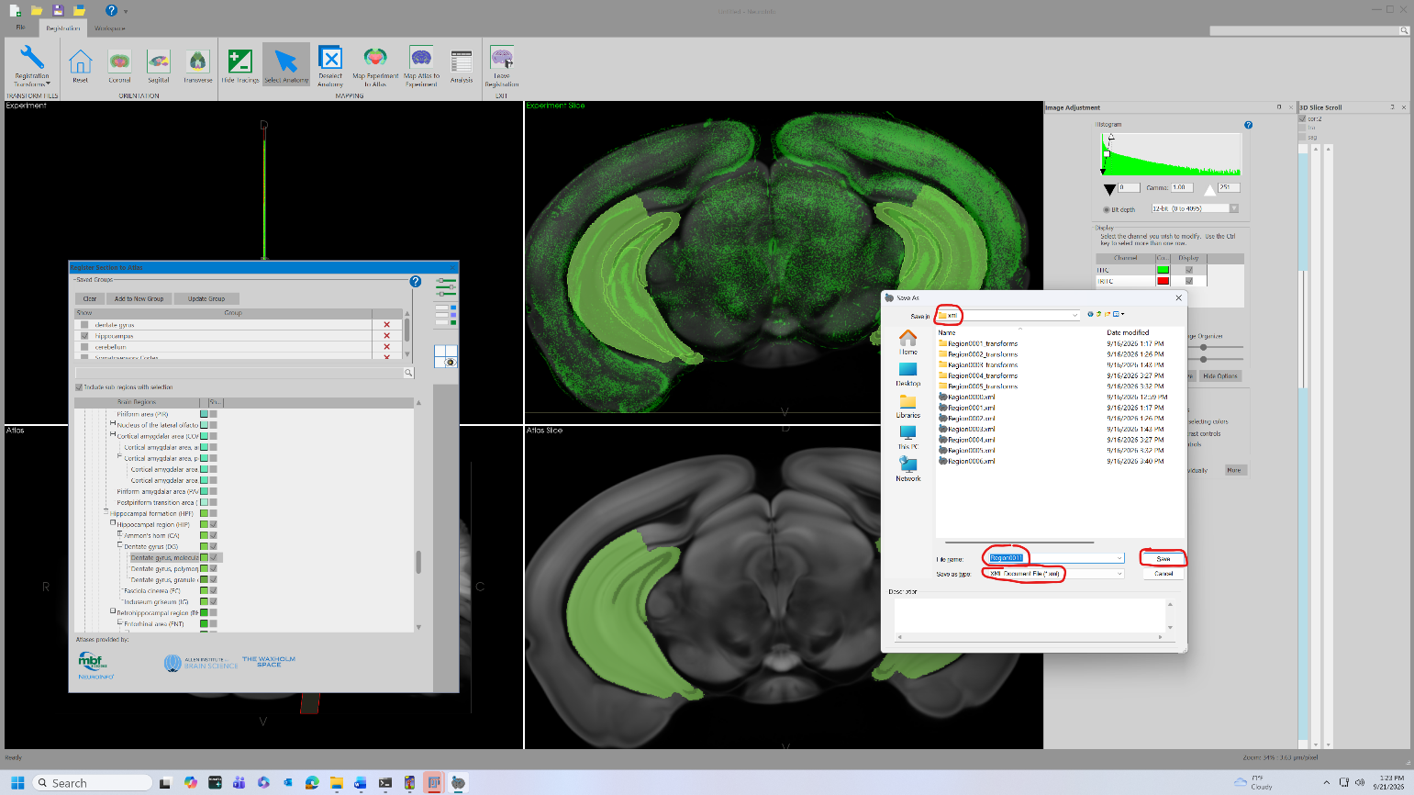
- Click Yes All to save the flattened .jpx stack into the jpx/ subfolder with the same naming, then click Export the image file. This step will fail if you click Save instead of Export.
Saved: Region0011.jpx
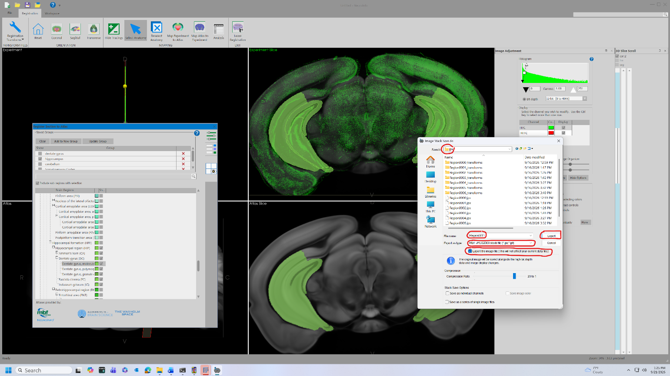

Reset workspace and continue to the next section
Do not open a new NeuroInfo instance for the next section. Reset the current workspace instead:
- Click the top-left-most icon (a paper with a green plus at its bottom right), labeled “Remove traced data and start a new data file,” or press Ctrl + N.
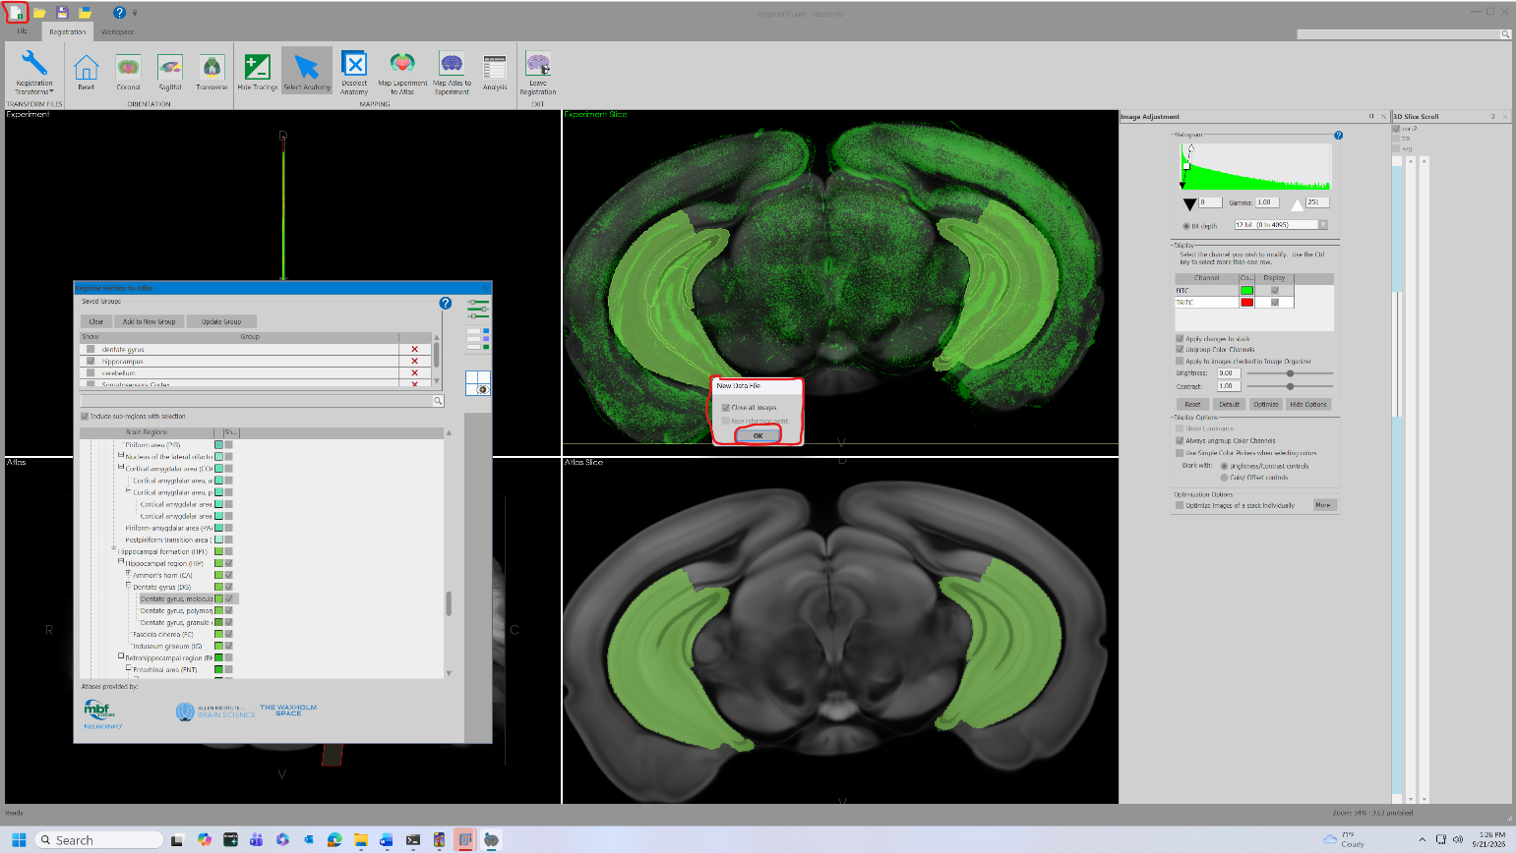
- Click “No” in the pop-up.
- Check “Close all images” and click “OK.”
- Return to the “Drag the desired .nd2 file” step and repeat through export for every section.
  - You may be able to load previous transforms to speed up time of alignment
  - Use file, load transform set, and select the transforms used for the prior section’s alignment to guide your new section’s alignment
End-of-stage check: the xml/ folder holds one contour file per section and the jpx/ folder holds the matching image stacks.

7. Stage 2: Convert nd2 to tif
- Run Plugins > Kapur Lab Cell Counting > Batch > 1 Convert to Tif. Give the slide folder and choose the "File type to convert" (.ims, the default, or .nd2). The script finds the nd2/ (or ims/) subfolder, or raw files directly in the slide folder, and writes a .tif for each file into the "tifs/" subfolder.
  - Note: The conversion script also runs a maximum intensity z-projection across all z-levels. Depending on your experimental conditions, this may not be desirable. To keep every z-level instead, untick "Run a z-projection".
  - 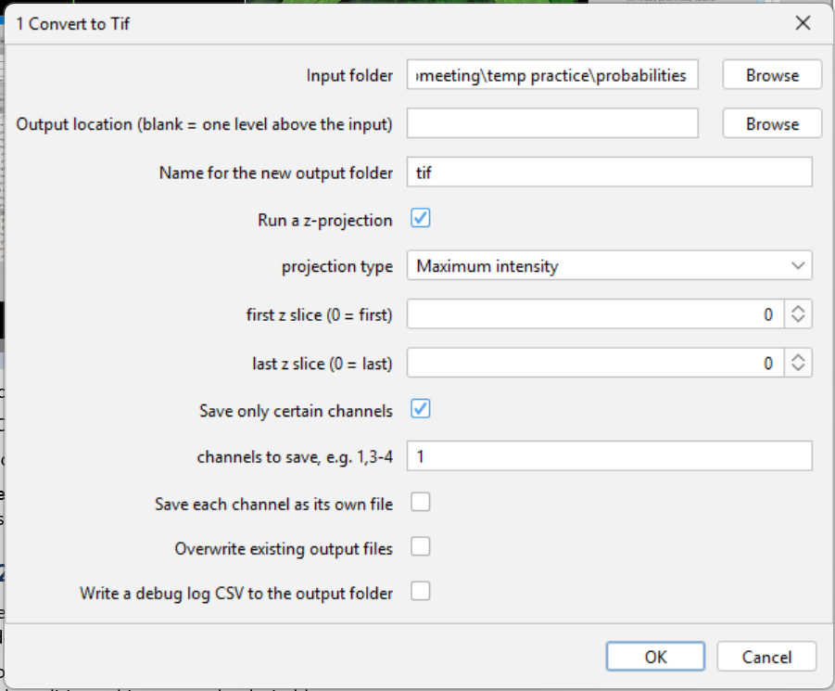
- Choose the channel you want to analyze: tick "Save only certain channels" and type its number in "channels to save" (for example, with NeuN in channel 1 and TRAP in channel 2, type 2 to count TRAP). The outputs go to the "tifs/" subfolder of the slide folder. Each name keeps the input name and adds the projection and channel, e.g. Region0011_ChannelFITCTRITC_Seq0011_MAX_C2.tif. If "Save only certain channels" is left unticked, every channel is saved, each as its own file.
Note: "File type to convert" decides which files are converted, so a folder that holds both .nd2 and .ims files converts only the type you choose. To convert one file only, use Single Image > 1 Convert to Tif (single).
End-of-stage check: tifs/ holds one .tif for each raw file (one per saved channel). Open one in Fiji to check that it shows the channel you want to count.

8. Stage 3: FIJI - build ROIs and subtract background

Convert XML contours to Fiji ROIs
- In FIJI, run Plugins > Kapur Lab Cell Counting > Batch > 2a NeuroInfo XML to ROI to convert all .xml files into Fiji ROI files.
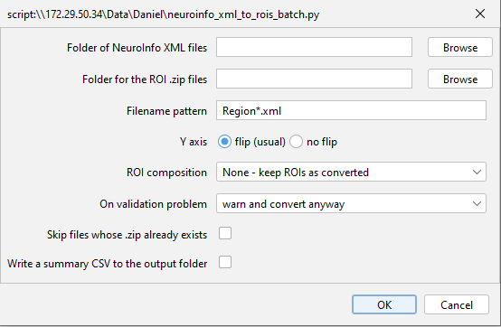
- Give the slide folder (and the region, if you made region folders). The script finds "xml/" and creates "rois/" next to it. Choose how ROIs should be combined; the other settings can usually be left at their defaults.
  - NeuroInfo exports every region you selected together with the regions inside it. Choose the "ROI composition" that fits your experiment:
Separate brain regions (the default): one count per brain region, for example the hippocampus, somatosensory cortex, striatum and amygdala counted separately in each section. In "regions to count" type the regions with ; between them, for example: Hippocampus; Somatosensory cortex; Striatum; Amygdala. Use region names as NeuroInfo writes them (the Log lists every name in your files before the run) or one of the groups the script knows: Hippocampus, Amygdala, Somatosensory cortex, Motor cortex, Dorsal striatum, Ventral striatum and PAG. Use the same list for every slide of the experiment so the results have the same columns. A section that does not contain a region gets NA for it in the results; a section with none of them is skipped.
Choose "hemispheres": Left and right separately (the default) counts each side on its own (Hippocampus-L and Hippocampus-R); Left and right together gives one count for both sides; Both gives all three.
Unify by hemisphere - left / right / unpaired: one count per hemisphere for everything NeuroInfo exported, when you do not need the regions apart.
Optional: count subregions too
To count the parts of a region as well (for example Field CA1, CA2, CA3 and the dentate gyrus of the hippocampus), tick "also count each subregion inside them separately". Every region NeuroInfo exported inside a counted region then gets its own count, next to the count for the whole region. To count only some parts, add them to "regions to count" instead, for example: Hippocampus; Field CA1; Field CA3; Dentate gyrus.
- At this point, ROIs can be inspected by opening the image they belong to (the raw .tif is best) and the ROI file in FIJI. Single Image > 2a NeuroInfo XML to ROI (single) does this for you: give the slide folder and the section, and it shows the new ROIs on the section's raw .tif. If the Log or the completion message of 2a lists sections under "Mirrored?" (left and right on the opposite side of the image from the other sections), check those sections with the pipeline composite (section 13). Such a section may have been flipped in NeuroInfo; its ROIs may then not line up with the tissue and its left and right counts may be swapped.
Optional: review and edit ROIs (2a.i)
If some outlines don't fit the tissue, run Batch > 2a.i Review and Edit ROIs (or the Single image version for one section). It opens each section's image with its ROIs, showing every channel overlaid in colour so you can see the anatomy (it uses the raw .nd2 file from nd2/ when tifs/ holds only one channel). "Channels on/off" turns channels on and off. Choose the ROI under "ROI to edit", then press "Reshape with the brush" (start inside the outline and drag to push the edge out, or start outside to cut it back), "Reshape by moving points" (drag the points of the outline; zoom in with + to see them) or "Redraw it by hand" (click around the new outline, double-click to close). Press "Keep this shape", then "Save changes" and OK. "Undo changes to this ROI" brings back the outline it had when the section opened. The original ROI set is kept in rois/_before_review/, and changes are logged in rois/_roi_review_log.csv. If you edit ROIs after running 2b or ilastik, run those again for the sections you changed; stage 5 warns you if an ROI set is newer than its images.

Background subtraction
- The key parameter for background subtraction is the rolling ball radius, which should be optimized for an experimental paradigm and then kept consistent across all images.
  - The general guidance is that the rolling ball radius should be “at least the size of the largest object that is not part of the background.” In practice, a smaller value ‘removes more background’ and a larger value ‘removes less background’. However, removing too much background can mean you lose real information. You can find an optimal value by opening one of your images and previewing the result of different radii using Process->Subtract background, or by using the optimization script (described at the end).
- Once an optimal value is determined, run the ROI background-subtraction script (Batch > 2b BG Subtract and Clear) with that value. Give the slide folder (and the region, if you made region folders); the script finds "tifs/" and "rois/". Set the "Rolling ball radius", what to clear outside ("Clear outside...", usually "union of ALL ROIs in the set") and the "Channel to process" (0 keeps every channel; leave it at 0 for the single-channel tifs from Stage 2). In most cases, you will only want to feed a single channel image into ilastik (the next step). This should be the channel containing the cells you are trying to count.
If “tifs/” holds more than one file per section (for example the _C1 and _C2 files from the converter), type the part of the name that picks the one you want (for example _C2) into “Only use images whose name contains”. The results go to “processed_bgsub_cleared/”, and each name gains _bgsub (plus _C<n> when you choose a single channel). These are the images to load into ilastik.
End-of-stage check: rois/ holds one .zip for each .xml, and processed_bgsub_cleared/ holds one _bgsub.tif for each section. Opened in Fiji, a _bgsub.tif shows the tissue with a darker background and everything outside the ROIs set to black.
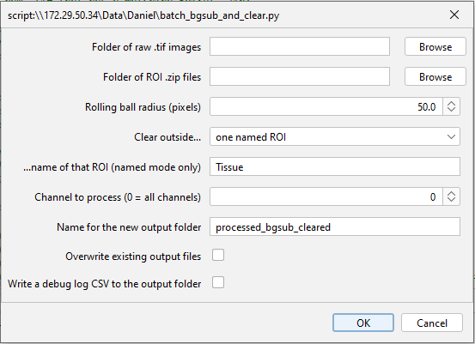

9. Stage 4: ilastik (Pixel Classification) - train and classify
A more detailed explanation of the ilastik pixel classification workflow can be found here.
- Start a new pixel classification project for the slide of images you are working with. Open ilastik, click Pixel Classification under "Create New Project", and save the project file in the slide folder (or in the region's folder, if you made one).
- Select your input data, which should be the background subtracted images (so the model doesn’t have to train on or classify extraneous information). Using ~30% of the images on your slide is a good rule of thumb. You may also be able to get away with less (or potentially train across multiple slides), but if your slices vary significantly in anatomy (i.e. you have cerebellar sections and cortical sections mixed in), lean on the side of including more images in the training. On the Input Data page, click "Add New..." > "Add separate Image(s)..." and choose the images in processed_bgsub_cleared/.
- For feature selection, select all features (click and drag).
- Train a Random Forest pixel-classification model (cell vs. background) using ilastik's interactive labeling. Be sure to have some labels on all images included in the training set.
  - Depending on your staining/imaging, you may not need to provide much labeling at all to get a good result. You can look at the uncertainty layer to determine where the model is having the hardest time classifying pixels. These areas are where additional labels are most useful.
  - In the “Training” section, rename the labels as “cell” and “background” by double-clicking the name
  - Then, for 10-20 cells, with the “cell” label, draw over only the cell, making sure you don’t draw over the black background
  - Then repeat by drawing over the background with the “background” label
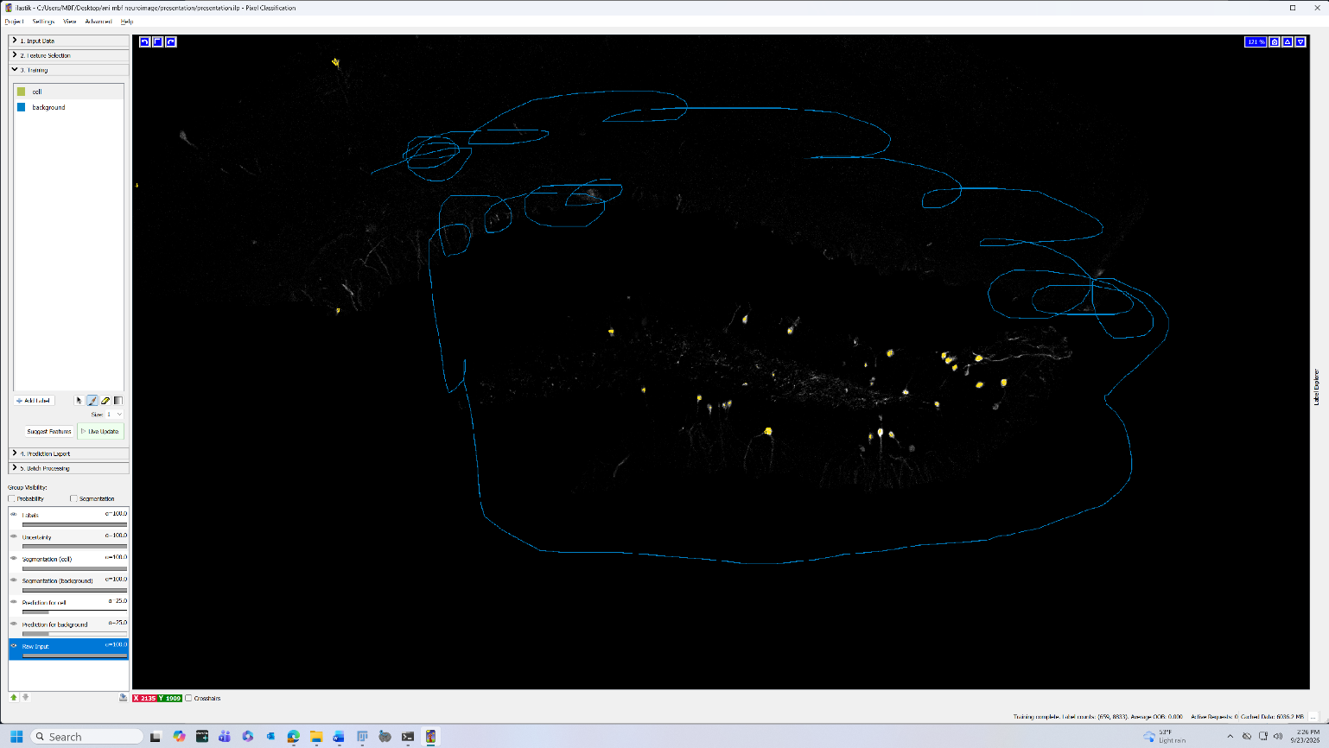
  - If you make any mistakes throughout the process, you can erase by clicking the erase tool at the bottom right of the “Training” section box
  - Once you’ve done this, click Live Update, and ensure that the model classified the cells accurately (if not, you may need to draw over more cells and repeat)
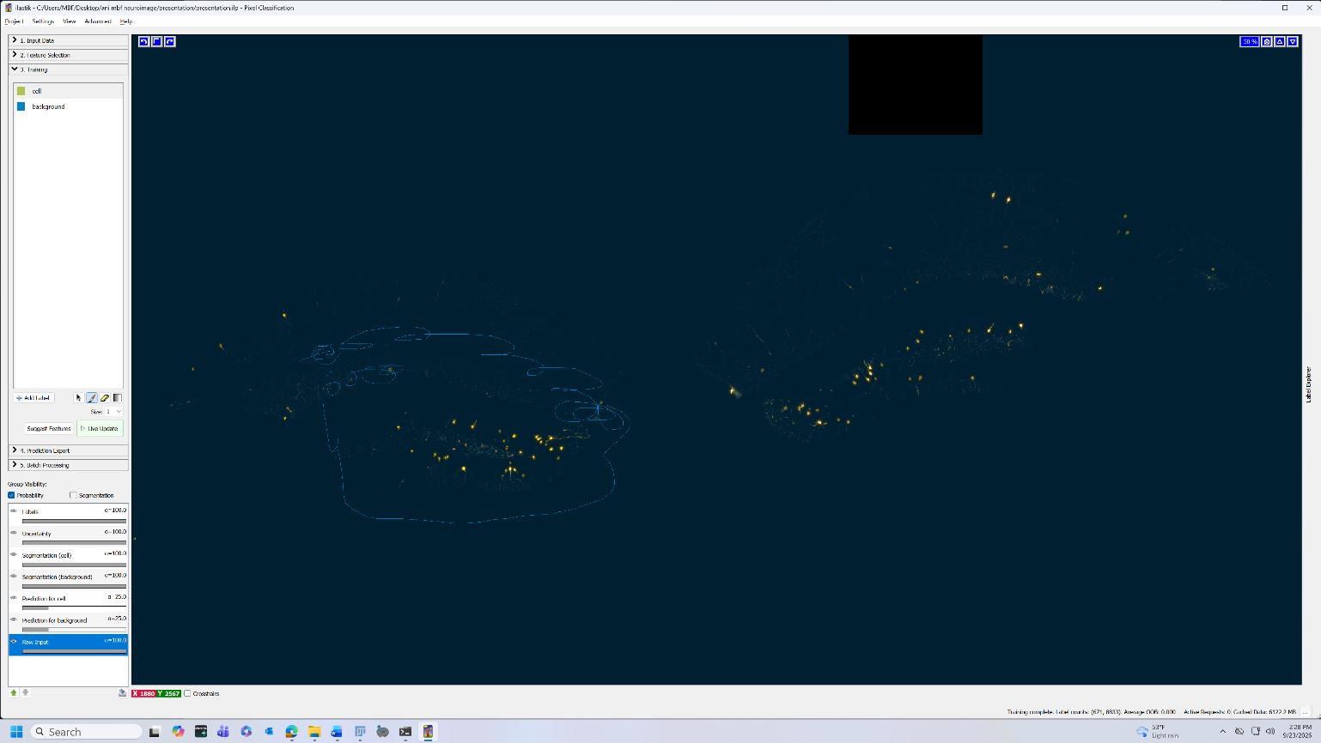
Optional: run the classifier from Fiji (2c Run ilastik Headless)
Steps 5 and 6 can be done in ilastik as written, or from Fiji. To use Fiji, make sure Live Update has run so the classifier is trained, save the project (Project > Save) into the slide folder, or the region's folder if you made one, and close ilastik. Then run Batch > 2c Run ilastik Headless and give it the slide folder. Fiji looks for ilastik in C:\Program Files; if it is installed somewhere else, click Browse next to "ilastik program" and choose ilastik.exe in the ilastik folder. The script runs the classifier you trained (the one Live Update showed, saved in the project) on every image in processed_bgsub_cleared/ and saves the maps to probabilities/ with the step 5 export settings already applied. It does not retrain the classifier, so every image is classified the same way. If the project was saved without a trained classifier, the script stops and asks you to turn on Live Update and save again. Images that already have a map are skipped unless "Overwrite existing probability maps" is ticked. Use the same ilastik version for the whole experiment. To use one project for every slide of an animal, add training images from several of its slides, save the project in the animal folder (the folder that holds the slide folders), and run 2c from Run Stages for an Animal (section 5.3) or on each slide: it finds the project there.
- Once the classifier looks good on the training subset, batch process all images (including the images included in the training) in ilastik (Batch Processing section). Then in the “Prediction Export” section: be sure to edit the prediction export settings (click “Choose Export Image Settings…”) in the following ways:
  - Source: probabilities
  - Convert to Data Type integer 8-bit
  - Renormalize [min, max] from: 0.00, 1.00 to 0, 255
  - Output File Info:
    - Format: tif
    - File: Click Select… and then navigate to your slide’s folder. Select (or create) the ‘probabilities’ subfolder, and then change the filename to: {nickname}.tif including the {}. Click save, and the File should now read: [path to folder]/probabilities/{nickname}.tif , where [path to folder] is the actual path to your actual folder. Never choose processed_bgsub_cleared/ here: ilastik would replace the background-subtracted images with probability maps. If you made region folders, the probabilities/ subfolder is inside the region's folder.
- Click on batch processing and select all images as raw data files, then click ‘process all files’ to export probabilities as .tif into the probabilities/ subfolder. This step will take some time.
- Inspect the output and, if you are unhappy with the results, continue to refine the random forest model. You may want to include more images in the training data.
End-of-stage check: probabilities/ holds one map for each section. Opened in Fiji, a map has two channels; channel 1 (cells) is bright where the cells are and dark elsewhere. If channel 1 is bright over the background instead, the labels were swapped in ilastik: label 1 must be the cells.

10. Optional: tune counting parameters from hand counts
Use this if you want the threshold, size and circularity values to be based on blind manual counts, for example when starting with a new marker or imaging setup. It needs the experiment table (section 5.1) and, for each section, a probability map and an ROI set (and a background-subtracted image if you count on it; see step 2). If you choose the values another way, skip to section 11.
- Run Plugins > Kapur Lab Cell Counting > Tune Counting Parameters. Give the experiment folder and, with region folders, the region. If a section has more than one image (for example _C1 and _C2), type the text that picks one into "Only use images whose name contains".
- Choose the "Image to count cells on". Probability map (after ilastik) is the default: use it when the images have a lot of background noise or axon signal, which ilastik has already removed, so the cells are easier to see. Background-subtracted image (before ilastik): use it when the neurons are clearly defined and separated and there is little noise. Counting on the map tunes the threshold, size and shape settings but cannot show cells that ilastik missed; counting on the background-subtracted image also checks ilastik.
- With the probability map, "also show the background-subtracted image as an extra channel" is ticked by default: each section opens with the map in magenta and the background-subtracted image in green, which helps to tell a cell from noise or an axon. Image > Color > Channels Tool turns either colour off. Untick it to see the map alone.
- Set the share of sections to count by hand (default 6%, at least 4 sections), the ROI the counting square must lie inside (blank = any ROI), the square size (default 300 pixels) and the probability channel that holds the cells.
- Sections are drawn at random across the groups of the experiment table and shown as "Section 1 of 6" and so on, without their group, so the counts are blind. For each section, move or resize the yellow square if needed, click the centre of every cell inside it with the multi-point tool, and press OK. Each count is saved as you go, so a session cut short can be reused.
- The script then tries every combination of threshold, watershed, size and circularity values and picks the one whose particles best match your clicks (F1 score). It writes tuned_counting_parameters_<region>.txt in the counting_tuning/ folder of the experiment folder, where stage 5 looks for it.
- Stage 5 uses these values by default for that region (its "Counting settings" field). To count with other values, choose "The values below". Keep "Exclude particles on edges" off in stage 5, as in the tuning.
With fewer than 4 sections counted, the completion message says the result is less certain; count more sections if the agreement is low.

11. Stage 5: FIJI - threshold and count
Run the batch thresholder + cell-counter macro (Batch > 3 Count Particles per ROI). Optimal values for the threshold, size filters, and circularity filters will need to be determined for an experimental paradigm and then kept consistent across all images.

Threshold
- Thanks to using ilastik’s pixel classification, all pixels have a value between 0 and 255 representing the ‘probability’ that that pixel is in the class represented by the channel (most likely channel 1 = cells and channel 2 = background). Consequently, we can use a simple threshold to select only for high probability pixels, and therefore ensure that nearby cells are not connected after thresholding, which would result in an undercount. A value of 128 (~50% probability) is a good starting point, but an optimal value should be found.
  - As with background subtraction, you can attempt to determine this optimal value either through trial and error or by using the optimization script. In FIJI, manual thresholds can be/are applied by going to Image->Adjust->Threshold…

Size and Circularity
- These are the most important parameters for the Analyze->Analyze Particles… command, and therefore for cell detection.
  - The minimum size filter must be set so as to exclude noise or other non-cellular objects that got thresholded in, while the maximum size filter must be set so as to exclude any large non-cellular objects. Since the chances of a large non-cellular object getting thresholded in are less than that of a small non-cellular objected getting thresholded in (especially if one uses the watershed command), the maximum filter can be more ‘lenient’.
  - Circularity is a measure of an object’s, well, circularity, where a value of 1.00 is a perfect circle. Since cells tend to be circular, leaving the maximum value at 1.00 is usually a safe bet. One mostly needs to optimize the minimum value in order to exclude certain things like axons (which can often be labeled in TRAP animals) or other linear artifacts (like the edges of the somatosensory cortex in NeuN staining), while still including all cells.
  - As before, all of these values will have to be optimized for your experimental paradigm and then kept consistent across all images. Trial and error on a few images or the optimization script will be useful.

Run the script
- Once optimal values have been found, and you know whether or not you want to watershed and fill holes, you can run the batch thresholder + cell-counter macro (Batch > 3 Count Particles per ROI). There are a few key settings:
  - The slide folder (and the region, if you made region folders). The script finds "probabilities/" and "rois/" and shows them for checking.
  - "Only use images whose name contains": leave it blank unless probabilities/ holds more than one map per section.
  - Whether or not you want to watershed (can help separate merged cells, but may also mistakenly introduce new cells)
  - Key parameters for Analyze Particles: minimum and maximum size, minimum and maximum circularity. Note that the size values are given in units of pixels² (rather than microns²), as we lose spatial calibration after ilastik export. This may be subject to change in the future.
  - Whether or not you want to include holes (count particles that have un-thresholded pixels within them. Unlikely after using ilastik but certainly possible, especially if using alternative thresholding methods).
  - "Exclude particles on edges": leaves out particles that touch the edge of the image. Keep it off unless you have a reason; after 2b, the tissue rarely touches the image edge.
  - What to ‘Show’ (either save masks as a new image, save outlines as a new image, or save nothing).
  - Whether or not and how to export the detected cells as ROIs (useful for overlaying against the original image to inspect your results).
  - The name of the new output folder.
  - "Counting settings": "Tuned values of the experiment (if found)" (the default) or "The values below". The first matters only if you ran the optional Tune Counting Parameters for this region. If no tuned values exist, the values in the dialog are used, and the Check settings window says so.
How cells are assigned to ROIs. Analyze Particles runs once on the whole image, and each particle is counted in every ROI that contains its centre. A particle in nested or overlapping ROIs (for example Field CA1 inside Ammon's horn) counts in each of them, so the ROI columns can add up to more than total_particles, which counts each particle once. Earlier versions counted every particle inside each ROI's bounding rectangle, which overcounted thin or curved regions; recount slides that were counted with those versions.
Probability maps. 8-bit maps are used as they are. 16-bit and 32-bit maps are converted on a fixed scale, so a threshold of 128 means a probability of about 0.50 in every map.
Reading the results. particle_counts/particle_counts.csv opens in Excel and has one row per section. The columns are the image name, the day, treatment, animal and slide (only if you ran Map Experiment Folders), the ROI file, n_rois, total_particles (each particle counted once), the threshold and watershed used, channel_means (a check that channel 1 is the cell channel), and then one column per ROI with its count. NA means that ROI is not in that section; it is not a count of zero. Running stage 5 again keeps the old table as particle_counts_previous_<date-time>.csv.
End-of-stage check: particle_counts.csv has one row per section. In the channel_means column, channel 1 should be much lower than channel 2 (cells cover a small part of the image); if not, stage 5 also prints a CHANNEL SANITY CHECK warning. Check a few sections with the pipeline composite (section 13).
particle_counts/particle_counts_by_region.csv has the same counts with one row per section and region: the region, the side (left, right, or blank for both), the count, the region's area in the section (pixels and mm2) and the cells per mm2. Sections cut at different levels hold different amounts of a region, so compare cells per mm2 as well as counts. This layout is the easiest to use in Prism, R or SPSS.

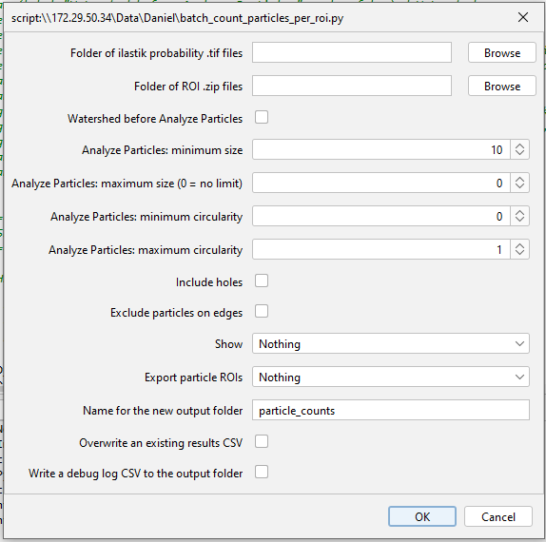

12. Optional: optimization script
Use this script if you want to compare parameter values by eye. You can also set the parameters by trial and error, or with Tune Counting Parameters (section 10).
The optimization script (Batch > 0 Optimize Parameters, or Single Image > 0 Optimize Parameters (single) to work on one section you choose) is a helpful tool when initially figuring the optimal values for background subtraction, thresholding, minimum and maximum size filters, and minimum and maximum circularity filters. The script will, holding all other parameters constant, run through either a designated or generated series of values for one of these parameters, and display the results as either a montage or an image stack. Visual inspection of the different results from these values can help you decide which one to use.

- Open and run the script in FIJI.
- Give the slide folder and choose the "Parameter to sweep". The script uses tifs/ for the rolling ball radius and probabilities/ for the other parameters, and shows the folder so you can change it.
  - In general, the background subtraction radius should be optimized on raw tifs, the threshold should be optimized on ilastik probability output tifs, and the size and circularity parameters can be optimized on either probabilities or on already thresholded images.
- Choose the values you want to test or specify how a range of values should be generated.
- Decide how many images you want the optimization to run on. Depending on how many values you are testing, increasing the number of images you test can dramatically increase running time. There is also a limit on how many images you can test on before the script will refuse to open the images as they are made, in order to prevent FIJI from freezing.
- Decide whether or not and how you want the image to be cropped before final display. If testing a lot of values, cropping can make things a bit easier.
- Set values for any required FIXED parameters. This mostly only applies if optimizing for parameters used in the Analyze Particles command; all other parameters need to be held fixed.
- Click ok, wait for the script to finish, and inspect the results. Each image should be annotated with the value used to generate it.

13. Optional: check your results with the pipeline composite
Recommended on a few sections of each slide, to check that detected cells line up with cells you can see in the raw image.
The pipeline composite script (Batch > 4 Build Pipeline Composite; the Single image version builds one section's composite) is a simple script which overlays any specified images and ROIs (either anatomical or detected cells or both) on top of each other in a simple image stack. This is probably most useful for seeing if the detected cells line up with cells that are visible in the raw tif image.

- Open and run the script in FIJI.
- Give the slide folder. The script finds tifs/, processed_bgsub_cleared/, probabilities/, the thresholded masks and particle ROIs from stage 5, and rois/, and shows them in a window. Clear any folder you do not want to overlay. The particle ROIs exist only if "Export particle ROIs" was set in stage 5.
- Specify channels to extract where appropriate and other display settings.
- Click ok, wait for the script to finish, and inspect the results.

